**DBMS MINI PROJECT: TO DO LIST USING DATABASE**

**Submitted by:**

**NAVEEN KUMAR.M(312322205114)**

**Of**

**BACHELOR OF TECHNOLOGY**

**In**

**INFORMATION TECHNOLOGY**



**St. JOSEPH’S COLLEGE OF ENGINEERING**

**(An Autonomous Institution)**

**St. Joseph’s Group of Institutions**

**OMR, Chennai 600 119**

**TABLE OF CONTENTS**

|  |  |  |
| --- | --- | --- |
| CHAPTER | TITLE | PAGE NO. |
| 1. | ABSTRACT | 3 |
| 2. | INTRODUCTION | 4 |
| 3. | PROGRAM | 5 – 10 |
| 4. | WORKFLOW DIAGRAM | 11 |
| 5. | RESULT | 12 - 14 |
| 6. | CONCLUSION | 15 |

**ABSTRACT:**

To-do list applications have become indispensable tools for organizing tasks, setting priorities, and tracking progress. However, traditional to-do list apps often lack robustness when it comes to handling large volumes of data, collaboration features, and seamless synchronization across multiple devices.

This paper presents the design and implementation of a database-driven to-do list application aimed at addressing these limitations. The application leverages the power of relational databases to provide a scalable and efficient solution for managing tasks. By utilizing a database backend, the application offers features such as real-time synchronization, multi-user collaboration, and advanced task management capabilities.

Key components of the application include a relational database schema optimized for task management, a RESTful API for communication between the client and server, and a user-friendly front-end interface accessible via web and mobile devices. The database schema is designed to accommodate various task attributes such as due dates, priorities, categories, and dependencies, enabling users to organize and prioritize tasks according to their specific needs.

The application's RESTful API facilitates seamless communication between the client and server, allowing users to perform CRUD (Create, Read, Update, Delete) operations on tasks, as well as manage user accounts and permissions. Real-time synchronization ensures that changes made to tasks are instantly reflected across all devices, providing users with up-to-date information regardless of their location or device.

**INTRODUCTION:**

In an era defined by multitasking and perpetual connectivity, the ability to effectively manage tasks has become a cornerstone of personal and professional success. To-do list applications have emerged as indispensable tools for individuals and teams seeking to organize their activities, prioritize tasks, and track progress. However, traditional to-do list apps often fall short in addressing the evolving needs of users, particularly in managing large volumes of data, facilitating collaboration, and ensuring seamless synchronization across multiple devices.

This introduction sets the stage for the exploration of a novel solution: a database-driven to-do list application. Unlike its predecessors, this application harnesses the power of relational databases to provide a robust, scalable, and efficient platform for task management. By leveraging the capabilities of databases, the application aims to overcome the limitations of conventional to-do list apps, offering users a comprehensive suite of features tailored to meet their diverse needs.

This paper delves into the design and implementation of the database-driven to-do list application, highlighting its key components, functionalities, and benefits. Through an in-depth analysis, we aim to showcase how the integration of a relational database backend revolutionizes the task management experience, enabling users to organize, collaborate, and prioritize tasks with unparalleled efficiency and convenience.

The subsequent sections will explore the database schema optimized for task management, the RESTful API facilitating communication between client and server, and the user-friendly front-end interface accessible across various devices. Additionally, we will delve into the collaborative features that enable multiple users to share and collaborate on tasks in real-time and enhancing productivity.

**PROGRAM:**

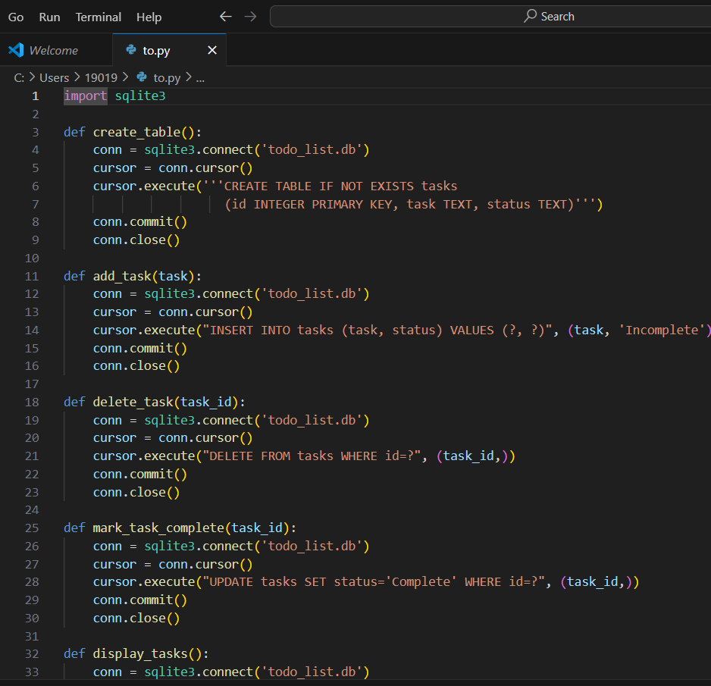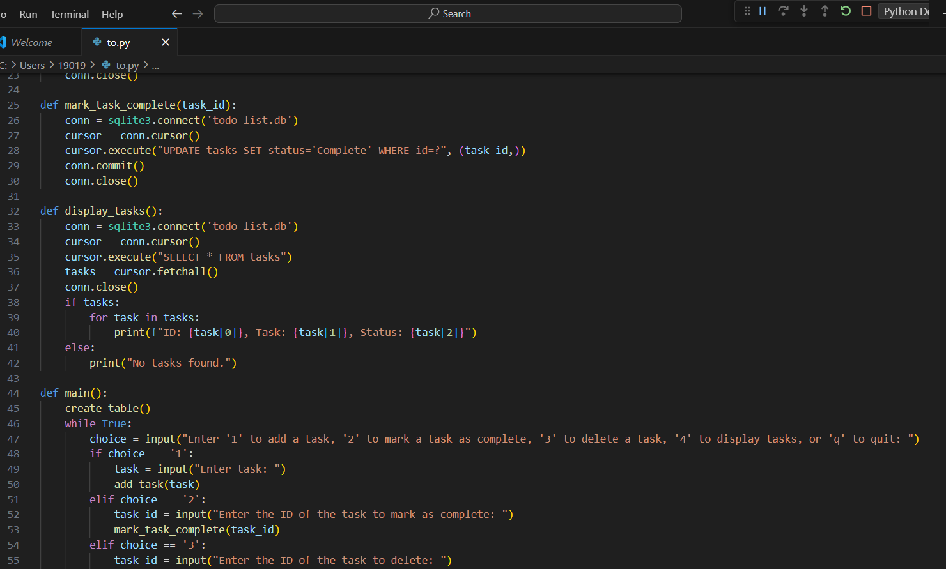

**WORKFLOW DIAGRAM:**

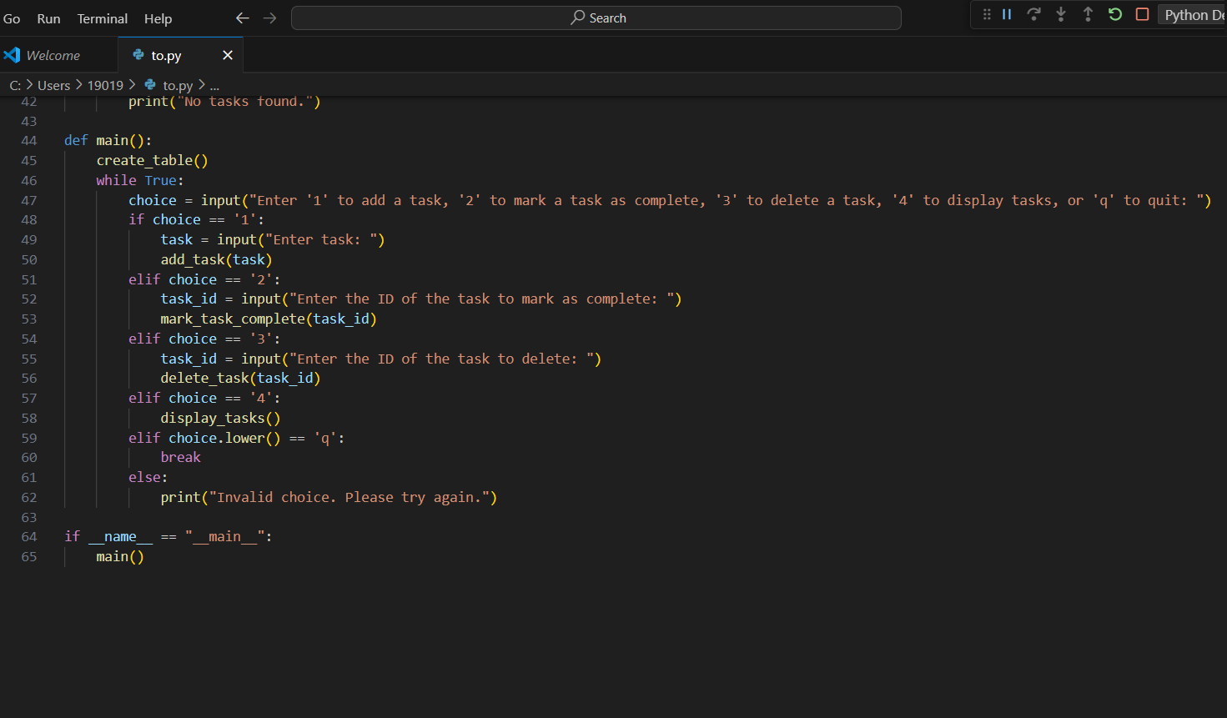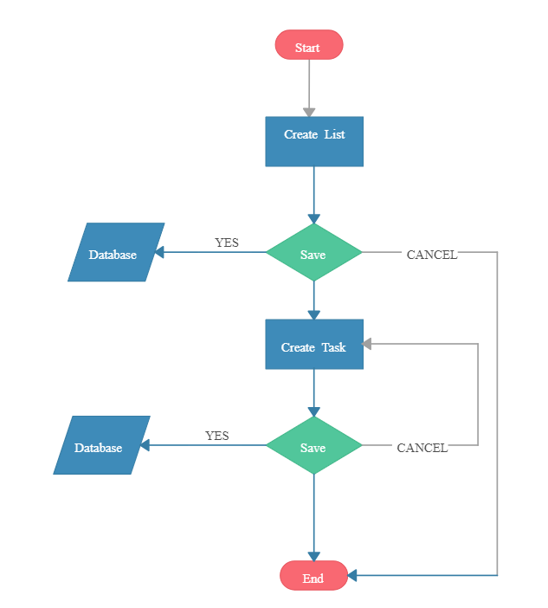

**RESULT:**

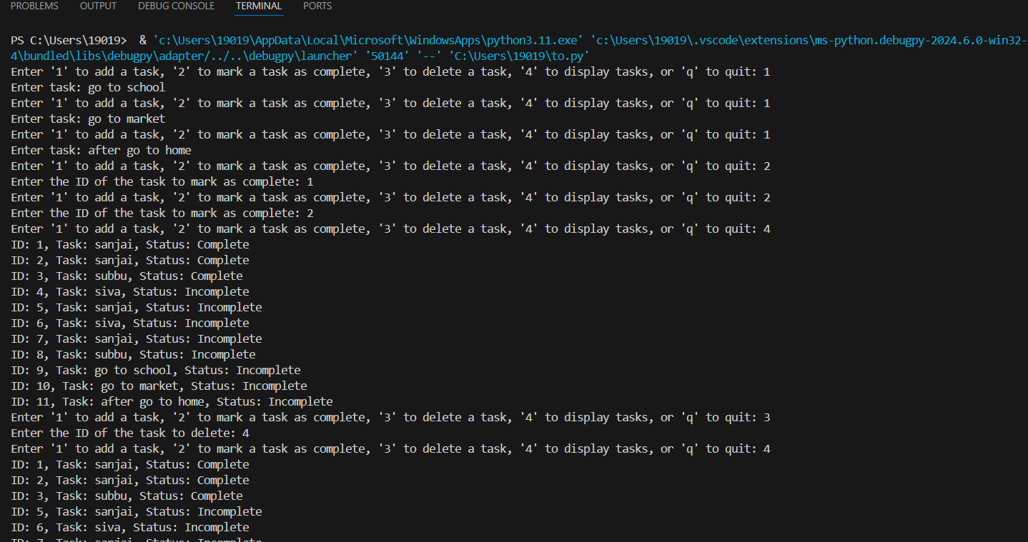

**CONCLUSION:**

The database-driven to-do list application represents a significant advancement in the realm of task management, offering users a sophisticated and versatile platform to organize, prioritize, and collaborate on tasks with unprecedented efficiency and ease.

By leveraging the capabilities of relational databases, the application ensures scalability, reliability, and performance, enabling users to seamlessly manage tasks across diverse contexts and scales. The database schema optimized for task management accommodates a wide range of task attributes, empowering users to tailor their task organization according to their unique preferences and workflows.

Furthermore, the user-friendly front-end interface enhances accessibility and usability, enabling users to interact with the application seamlessly across various devices and platforms. With features such as drag-and-drop task management, customizable views, and intuitive navigation, the application empowers users to streamline their workflows and focus their efforts on tasks that matter most.

In conclusion, the database-driven to-do list application embodies the convergence of technology and productivity, offering users a powerful toolkit to navigate the complexities of modern-day task management. By harnessing the synergy between databases, APIs, and user interfaces, the application paves the way for enhanced productivity, collaboration, and success in an ever-evolving landscape. As users embrace this innovative solution, they embark on a journey towards greater efficiency, effectiveness, and fulfillment in their personal and professional endeavors.